Code files:



Case 1:

01 Jan 2014 - 30 Jan 2014

15 Jan 2014 - 15 Feb 2014

10 Mar 2014 - 15 Apr 2014

10 Apr 2014 - 15 May 2014

The output should be:

01 Jan 2014 - 15 Feb 2014

10 Mar 2014 - 15 May 2014

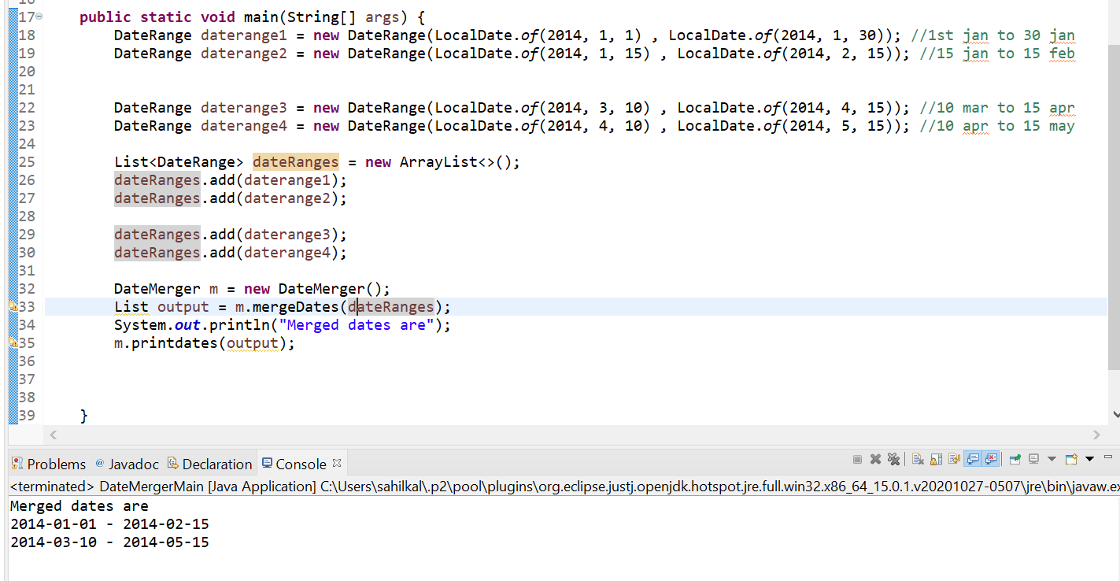

Case 2:

If start date of a date range is greater than end date of another date range, then do not merge those date ranges. For example, the below date ranges should not be merged:

01 Jan 2014 – 15 Jan 2014

16 Jan 2014 – 30 Jan 2014

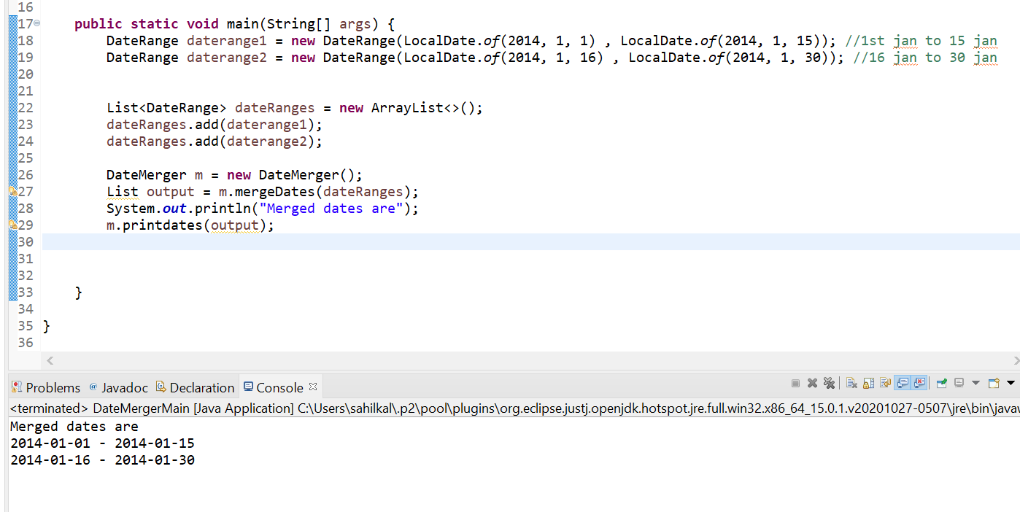

Case 3:

Below date ranges should be merged:

01 Jan 2014 – 15 Jan 2014

15 Jan 2014 – 30 Jan 2014

